Chapter 1

**Introduction**

**Digital Attendance Management System(DAMS)** software is prepared to maintain the day to day operations in a leading collage. This software helps them to maintain the student and employee records. So the maintenance becomes easier.

The main objective of Digital Attendance Management system is to automate all attendance of a college or university. Using this DAMS you can view or update data and information about students and staff easily. This system helps in managing the activity like Student registration, Student details updating , Student attendance. Admin can also retrieve information of employee student.

Digital Attendance Management System(DAMS) can be used to store student information like attendance , Student information . Admin can create report regarding any student any time using this system. Using this system you can register new student and their course details . Admin can also add new staff in the system and can check details of the staff easily.

Using this system you can manage all information of all aspects of a college, its students, faculties, Departments. Digital Attendance management system provides the easiest way to manage all functionalities of a college. This system facilitates colleges to maintain the functionality related to college staffs and their students.

Digital Attendance Management System(DAMS) can store and manage all data of   the various departments of a college like Attendance, Staff details etc. using this system user can retrieve any information related to student and teacher . Using this system teacher can check student attendance anytime .

Digital Attendance Management System(DAMS) deals with all kind of student details, academic related reports, college details, course details, and other resource related details too. It tracks all the details of a student from the day one to the end of his course which can be used for all reporting purpose, tracking of attendance, progress in the course, completed semesters years, coming semester year curriculum details, exam details, project or any other assignment details . Our program will have the databases of Courses offered by the college under all levels of graduation or main streams, teacher or faculty's details, students details in all aspects. This program can facilitate us explore all the activities happening in the college, even we can get to know which teacher / faculty is assigned to which batch, the current status of a batch, attendance percentage of a batch and upcoming requirements of a batch. Different reports and Queries can be generated based of vast options related to students, course, teacher / faculty, semesters and even for the entire college.

Digital Attendance Management System (DAMS) is an automated version of manual Student Management System. It can handle all details about a student. The details include college details, subject details, student personnel details etc... In case of manual system they need a lot of time, manpower etc. Here almost all work is computerized. So the accuracy is maintained. Maintaining backup is very easy. It can do with in a few minutes. Our system has two type of accessing modes, administrator and user. Student management system is managed by an administrator. It is the job of the administrator to insert update and monitor the whole process.

Digital Attendance Management System (DAMS) is an integrated web application that handles various academic activities of a College/Academic Institute. The system can access by every faculties/employees of the institution through internet connected computers or internet enabled mobile devices with the aid of his email and password. Every user will have a customized home page with his/her profile management facilities and the user can update his information whenever he/she wants. Though the system allows access to every one there is a significant security provided in this project is **EMAIL VERIFICATION** without verifying the email the user/staff cannot login into our system . Only trusted and verified users can access these modules. Although a standard password policy will be followed in the designing of the system to prevent the possibilities of malicious activities of itching users. A self-driven module in the proposed system will accomplish the automated tasks such as Email Alerts , Notifications to the administrator etc.

Chapter 2

**Objectives**

**2.1 Objective and scope**

The main goal of the application is to maintain the attendance records of collage, this software is helpful to the collages to maintain the student and staff management.

This is for generic type software, suitable to all collages. This software have all the modules to manage collage transactions, Objective & Scope This is a web oriented application allows us to access the whole information about the college, staffs, students, facilities etc. This application provides a virtual tour of Campus. Here we will get the latest information about the students and staffs. This generic application designed for assisting the students of an institute regarding information on the courses, subjects, classes . It also provides support that a faculty can also check about his daily schedule, can upload assignments, and notices to the students.

**Information about Student**: It will help in maintaining complete information about student such as their semester , email , mobile number , address etc. Staff will register new student and remove their account when they are detained or Passed out.

**Student attendance status**: It gives the attendance status of students. Faculty will update the attendance daily and can be seen by admin .Admin can also send the status attendance of the student to their parents .

**Information about staff**: It will help in maintaining complete information about college faculty members such as their department, designation , date of joining, salary, etc. Administrator will register new faculties and remove their account when they leave the college.

**2.2Benefits of DAMS**

The benefits of Digital Attendance Management System(DAMS) for the staff are they can easily retrieve all information related to Student and Staff. Admin has all the Collective records of Students of all the branches. Admin can check all the records of employees of all departments anytime. This system gives easy approach to find the detail information for any student/employee. Using this Digital Attendance management System it is very easy to handle attendance functionality of college. This system is beneficial for both students and employees as they can get all previous or current information when they need. This system is also helpful to maintain the student’s record like Student’s Personal information , Student attendance status . Digital Attendance management System can help to get all or a particular student attendance information.  This system also helps to generate automated bar chart of students Attendance status .

**2.3 Existing System**

The Existing system is a manual entry for the students. Here the attendance will be carried out in the hand written registers. It will be a tedious job to maintain the record for the user. The human effort is more here. The retrieval of the information is not as easy as the records are maintained in the hand written registers. This application requires correct feed on input into the respective field. Suppose the wrong inputs are entered, the application resist to work. so the user find it difficult to use.

Apart from that OBE based Education is introduced hence there is no Applications are not yet designed to store and process the OBE based data

**2.4 Proposed System**

To overcome the drawbacks of the existing system, the proposed system has been evolved. This project aims to reduce the paper work and saving time to generate accurate results from the student’s attendance. The system provides with the best user interface. The efficient reports can be generated by using this proposed system.

Advantages of Proposed System

* It is trouble-free to use.
* It is a relatively fast approach to enter attendance
* Is highly reliable, approximate result from user
* Best user Interface
* Efficient reports

Chapter 3

**Tools/Environment used**

|  |  |
| --- | --- |
| H **Hardware Requirements** | |
| P Processor | Pentium IV 2GHz and above |
| RAM | 2GB RAM |
| Monitor | 15’’ Color Monitor |
| Keyboard | |
| Mouse | |
| Smart Phone ( Android version 4.2 and Above ) | |

|  |  |
| --- | --- |
| **SSoftware Requirements** | |
| Operating System | Windows 7 or Above |
| Web Browser | IE8.0/Opera/ Google |
| User Interface | HTML, CSS |
| Client-side Scripting | JaJavaScript,HTML,CSS ,J query |
| Server side scripting | PHP,Java script |
| Programming Language | PHP |
| WebHosting service | 000WebHosting service |
| IDE/Workbench | Sublime text v3 |
| Database | PhpMyAdmin |
| Server Deployment | Apache |

Chapter 4

**Analysis Document**

**4.1 System Design**

Software design sits at the technical kernel of the software engineering process and is applied regardless of the development paradigm and area of application. Design is the first step in the development phase for any engineered product or system. The designer’s goal is to produce a model or representation of an entity that will later be built. Beginning, once system requirement has been specified and analyzed, system design is the first of the three technical activities -design, code and test that is required to build and verify software.

The importance can be stated with a single word “Quality”. Design is the place where quality is fostered in software development. Design provides us with representations of software that can assess for quality. Design is the only way that we can accurately translate a customer’s view into a finished software product or system. Software design serves as a foundation for all the software engineering steps that follow. Without a strong design we risk building an unstable system – one that will be difficult to test, one whose quality cannot be assessed until the last stage.

During design, progressive refinement of data structure, program structure, and procedural details are developed reviewed and documented. System design can be viewed from either technical or project management perspective. From the technical point of view, design is comprised of four activities – architectural design, data structure design, interface design and procedural design.

**4.2 DATA FLOW DIAGRAM**

**DFD Level 0**

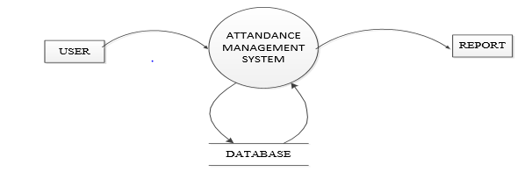

**Fig 4.2.1 : Data flow diagram level 0**

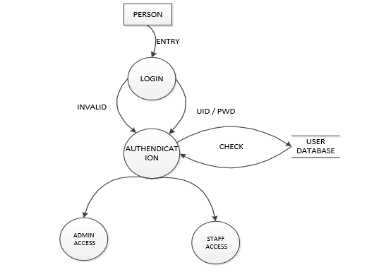

**Fig 4.2.2 : Data flow diagram level 1**

**DFD Level 2**

**Admin :**

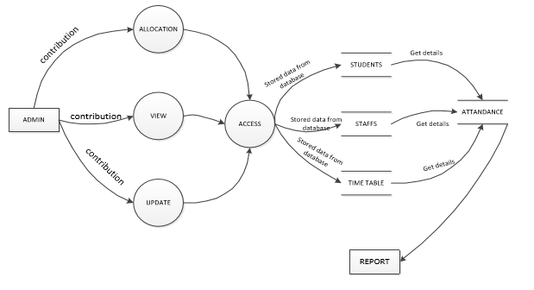

**Fig 4.2.3 : Data flow diagram level 2.1**

**Staffs:**

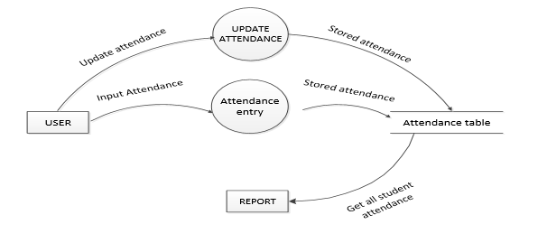

**Fig 4.2.4 : Data flow diagram level 2.2**

**4.3 DESIGN DOCUMENT**

Some of the features of the proposed system are

1. Student Attendance Management

2. Student Report

Digital Attendance Management System(DAMS) can be used to manage the data of all type of educational institutes. It will support both stand alone and also networking environment. The system uses VB. Net Technology. The main modules involved in this system are:

1. Login

2. Forms

3. Reports

4. Window

Module wise description

Login module is used to check whether the user is an authorized person to use the system or not. For this the user should give the correct user name and password.

The different types of users are

1. Admin

2. Staff

**Reports**

All the above mentioned data are stored in the back end and can be retrieved as reports with filtering options

* Report in PDF

The application provides appropriate information to users according to the chosen service.

The project is designed keeping in view the day to day problems faced by a college.

Deployment of our application will certainly help the college to reduce unnecessary wastage of time in personally going to each department for some information

Awareness and right information about any college is essential for both the development of student as well as faculty.

**4.4 Use Case Diagram**

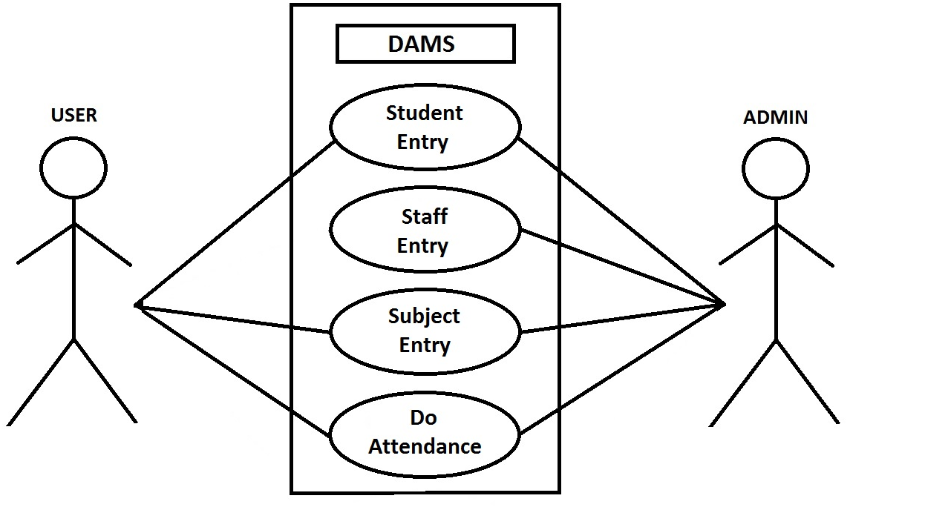

**Fig: 4.1 Use Case diagram for Data Entry**

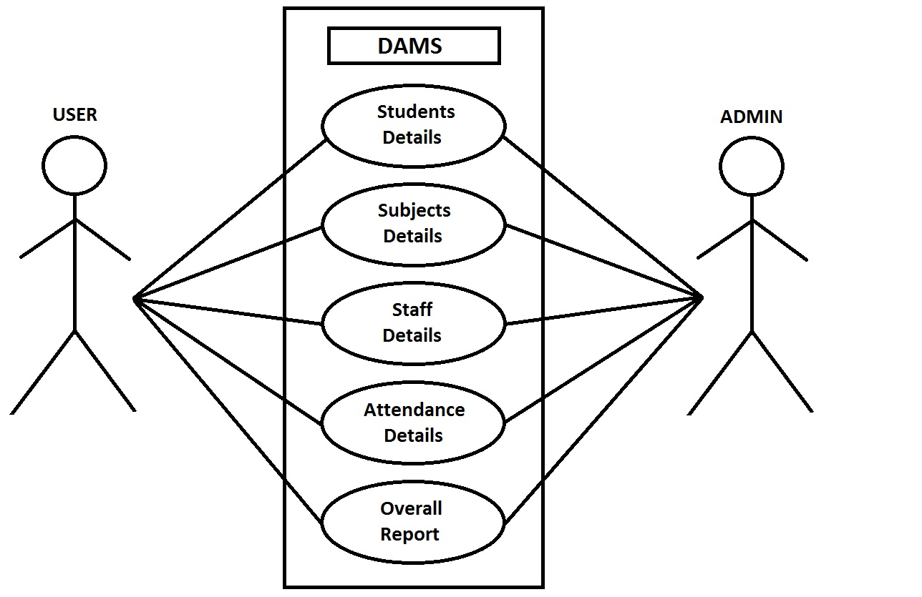

**Fig: 4.1 Use Case diagram for Details**

**4.5 ER Diagram:**

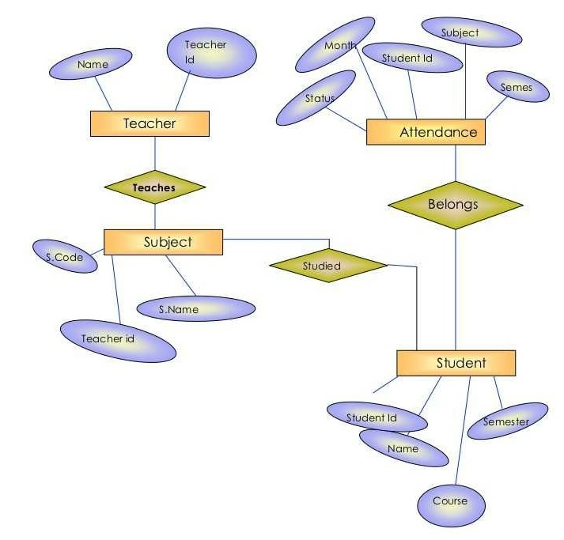

**Fig 4.5 : ER Diagram for DAMS**

Chapter 5

**System Environment**

We use PHP as programing language to develop a project and we use Apache server and MySQL database to store data.

**5.1 About PHP**

**PHP** is a server side scripting language designed for web development but also used as a general purpose programming language. Originally created by RasmusLerdorf in 1994, the PHP reference implementation is now produced by The PHP Group. PHP originally stood for Personal Home Page, but it now stands for the recursive acronym PHP: Hypertext Pre-processor.

PHP code may be embedded into HTML code, or it can be used in combination with various web template systems, web content management system and web frameworks. PHP code is usually processed by a PHP interpreter implemented as a module in the web server or as a Common Gateway Interface (CGI) executable. The web server combines the results of the interpreted and executed PHP code, which may be any type of data, including images, with the generated web page. PHP code may also be executed with a command-line interface (CLI) and can be used to implement standalone graphical.

**5.2. About phpMyAdmin:**

**PhpMyAdmin Interface**

phpMyAdmin is a web-based interface to a MySQL server. The interface is written in the PHP language, which is frequently used for web-based interactive programs. phpMyAdmin translates what you enter into the web browser, sends queries to the MySQL database, and translates the returned information back to web format. As we will see, there are other ways to access the MySQL database, including directly from Mathematica

**5.3 About Apache**

Apache is a most widely used web server software. Developed and maintaned by apache Software Foundation. Apache is a open source software available for free . It runs on 67% of all web servers in the world . It is fast , reliable and Secure . It can be Highly Customized to meet the needs of many different environments by using extensions and Modules. In 2009 it became the first webserver software to serve more than a 100 million websites . source

Chapter 6

**Testing**

**6.1 SYSTEM TESTING**

Testing defines the status of the working functionalities of any particular system. Through testing particular software one can’t identify the defects in it but can analyses the performance of software and its working behaviour. By testing the software, we can find the limitations that become the conditions on which the performance is measured on that particular level. In order to start the testing, process the primary thing is requirements of software development cycle. Using this phase, the testing phase will be easier for testers. The capacity of the software can be calculated by executing the code and inspecting the code in different conditions such as testing the software by subjecting it to different sources as input and examining the results with respect to the inputs.

The purpose of testing is to discover errors. Testing is the process of trying to discover every conceivable fault or weakness in a work product. It provides a way to check the functionality of components, sub-assemblies, assemblies and/or a finished product It is the process of exercising software with the intent of ensuring that the

Software system meets its requirements and user expectations and does not fail in an unacceptable manner. There are various types of test. Each test type addresses a specific testing requirement.

**6.2 TYPES OF TESTING:**

**6.2.1 UNIT TESTING:**

Unit testing involves the design of test cases that validate that the internal program logic is functioning properly, and that program inputs produce valid outputs. All decision branches and internal code flow should be validated. It is the testing of individual software units of the application .it is done after the completion of an individual unit before integration. This is a structural testing, that relies on knowledge of its construction and is invasive. Unit tests perform basic tests at component level and test a specific business process, application, and/or system configuration. Unit tests ensure that each unique path of a business process performs accurately to the documented specifications and contains clearly defined inputs and expected results.

**6.2.2 INTEGRATION TESTING:**

Integration tests are designed to test integrated software components to determine if they actually run as one program. Testing is event driven and is more concerned with the basic outcome of screens or fields. Integration tests demonstrate that although the components were individually satisfaction, as shown by successfully unit testing, the combination of components is correct and consistent. Integration testing is specifically aimed at exposing the problems that arise from the combination of components.

**6.2.3 FUNCTIONAL TEST:**

Functional tests provide systematic demonstrations that functions tested are available as specified by the business and technical requirements, system documentation, and user manuals.

Functional testing is centered on the following items:

Valid Input : identified classes of valid input must be accepted.

Invalid Input : identified classes of invalid input must be rejected.

Functions : identified functions must be exercised.

Output : identified classes of application outputs must be exercised.

Systems/Procedures: interfacing systems or procedures must be invoked.

Organization and preparation of functional tests is focused on requirements, key functions, or special test cases. In addition, systematic coverage pertaining to identify Business process flows; data fields, predefined processes, and successive processes must be considered for testing. Before functional testing is complete, additional tests are identified and the effective value of current tests is determined.

**6.2.4 SYSTEM TEST:**

System testing ensures that the entire integrated software system meets requirements. It tests a configuration to ensure known and predictable results. An example of system testing is the configuration oriented system integration test. System testing is based on process descriptions and flows, emphasizing pre-driven process links and integration points.

**6.2.5 WHITE BOX TESTING:**

White Box Testing is a testing in which in which the software tester has knowledge of the inner workings, structure and language of the software, or at least its purpose. It is purpose. It is used to test areas that cannot be reached from a black box level.

**6.2.6 BLACKBOX TESTING:**

Black Box Testing is testing the software without any knowledge of the inner workings, structure or language of the module being tested. Black box tests, as most other kinds of tests, must be written from a definitive source document, such as specification or requirements document, such as specification or requirements document. It is a testing in which the software under test is treated, as a black box. you cannot “see” into it. The test provides inputs and responds to outputs without considering how the software works.

**6.2.7 UNIT TESTING:**

Unit testing is usually conducted as part of a combined code and unit test phase of the software lifecycle, although it is not uncommon for coding and unit testing to be conducted as two distinct phases.

**Test strategy and approach:**

Field testing will be performed manually and functional tests will be written in detail.

**Test objectives:**

* All field entries must work properly.
* Pages must be activated from the identified link.
* The entry screen, messages and responses must not be delayed.

**Features to be tested**

* Verify that the entries are of the correct format
* No duplicate entries should be allowed
* All links should take the user to the correct page.

# 6.2.8 INTEGRATION TESTING:

Software integration testing is the incremental integration testing of two or more integrated software components on a single platform to produce failures caused by interface defects.

The task of the integration test is to check that components or software applications, e.g. components in a software system or – one steps up – software applications at the company level – interact without error.

**Test Results:** All the test cases mentioned above passed successfully. No defects encountered.

**6.2.9 ACCEPTANCE TESTING:**

User Acceptance Testing is a critical phase of any project and requires significant participation by the end user. It also ensures that the system meets the functional requirements.

**Test Results:** All the test cases mentioned above passed successfully. No defects encountered.

**6.3 TESTCASES:**

|  |  |  |  |  |  |  |  |
| --- | --- | --- | --- | --- | --- | --- | --- |
| Test case ID | Test case name | Test case description | Test steps | | | | Test status P/F |
| Step | I/p given | Expected o/p | Actual o/p |
| TC01 | Login | To verify Admin/User  Registered | User login | Email  &Password | Login Successfully | Login Successfully | Pass |
|  | Login | To verify Admin/User  Registered | Non Registered User login | Email &Password | Error message  “ User does not Exist ” | Error message  “ User does not Exist ” | Pass |

**Table 6.1 Test Cases for Login**

|  |  |  |  |  |  |  |  |
| --- | --- | --- | --- | --- | --- | --- | --- |
| Test case ID | Test case name | Test case description | Test steps | | | | Test status P/F |
| Step | I/p given | Expected o/p | Actual o/p |
| TC02 | Signup | To signup  New user | User Signup | Username , Email &Password | Signup Successfully.  Verification mail is Sent | Signup Successfully.  Verification mail is Sent | Pass |
|  | Signup | To signup  New user | Existing Registered User Signup | Username , Email &Password | Error message  “ Email Already Registered” | Error message  “ Email Already Registered” | Pass |

**Table 6.2 Test Cases for Signup**

|  |  |  |  |  |  |  |  |
| --- | --- | --- | --- | --- | --- | --- | --- |
| Test case ID | Test case name | Test case description | Test steps | | | | Test status P/F |
| Step | I/p given | Expected o/p | Actual o/p |
| TC03 | Insert Student | To Insert the  New Student | Insertion of Student | Enter the details in the Form | Inserted Successfully. | Inserted Successfully. | Pass |
|  | Delete Student | To Delete Existing Student | Deletion of Student | Click on Delete | Deleted Successfully. | Deleted Successfully. | Pass |
|  | Update  Student | To Update Existing Student  data | Updation of Student | Enter the details to be Updated | Updated Successfully. | Updated Successfully. | Pass |

**Table 6.3 Test Cases for Student Module**

|  |  |  |  |  |  |  |  |
| --- | --- | --- | --- | --- | --- | --- | --- |
| Test case ID | Test case name | Test case description | Test steps | | | | Test status P/F |
| Step | I/p given | Expected o/p | Actual o/p |
| TC04 | Insert Teacher | To Insert the  New Teacher | Insertion of Teacher | Enter the details in the Form | Inserted Successfully. | Inserted Successfully. | Pass |
|  | Delete Teacher | To Delete Existing Teacher | Deletion of Teacher | Click on Delete | Deleted Successfully. | Deleted Successfully. | Pass |
|  | Update  Teacher | To Update Existing Teacher  data | Updation of Teacher | Enter the details to be Updated | Updated Successfully. | Updated Successfully. | Pass |

**Table 6.4 Test Cases for Teacher Module**

|  |  |  |  |  |  |  |  |
| --- | --- | --- | --- | --- | --- | --- | --- |
| Test case ID | Test case name | Test case description | Test steps | | | | Test status P/F |
| Step | I/p given | Expected o/p | Actual o/p |
| TC05 | Insert Subject | To Insert the  New Subject | Insertion of Subject | Enter the details in the Form | Inserted Successfully. | Inserted Successfully. | Pass |

**Table 6.5 Test Cases for Subject Module**

|  |  |  |  |  |  |  |  |
| --- | --- | --- | --- | --- | --- | --- | --- |
| Test case ID | Test case name | Test case description | Test steps | | | | Test status P/F |
| Step | I/p given | Expected o/p | Actual o/p |
| TC06 | Do Attendance | To Track the Attendance | Student Present | Select Name, Subject,Present | Tracked Successfully as Present. | Tracked Successfully as Present. | Pass |
|  | Do Attendance | To Track the Attendance | Student Absent | Select Name, Subject,Absent | Tracked Successfully as Absent. | Tracked Successfully as Absent. | Pass |

**Table 6.6 Test Cases for Tracking the Attendance**

Chapter 7

**Screen Shots**

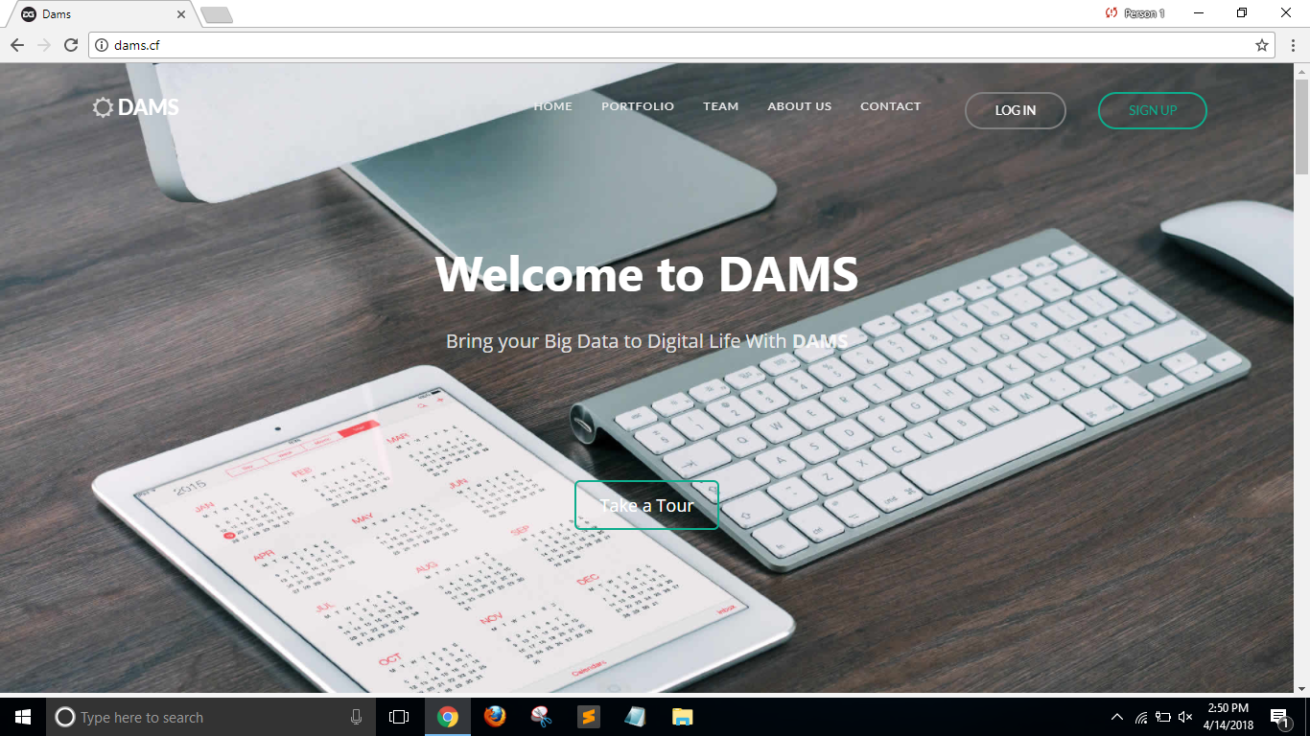

**Fig 7.1 : Home Page**

**In ‘Home Page’ Admin and staff can login through there username and password.**

**Feedback is also provided in the Home page.**

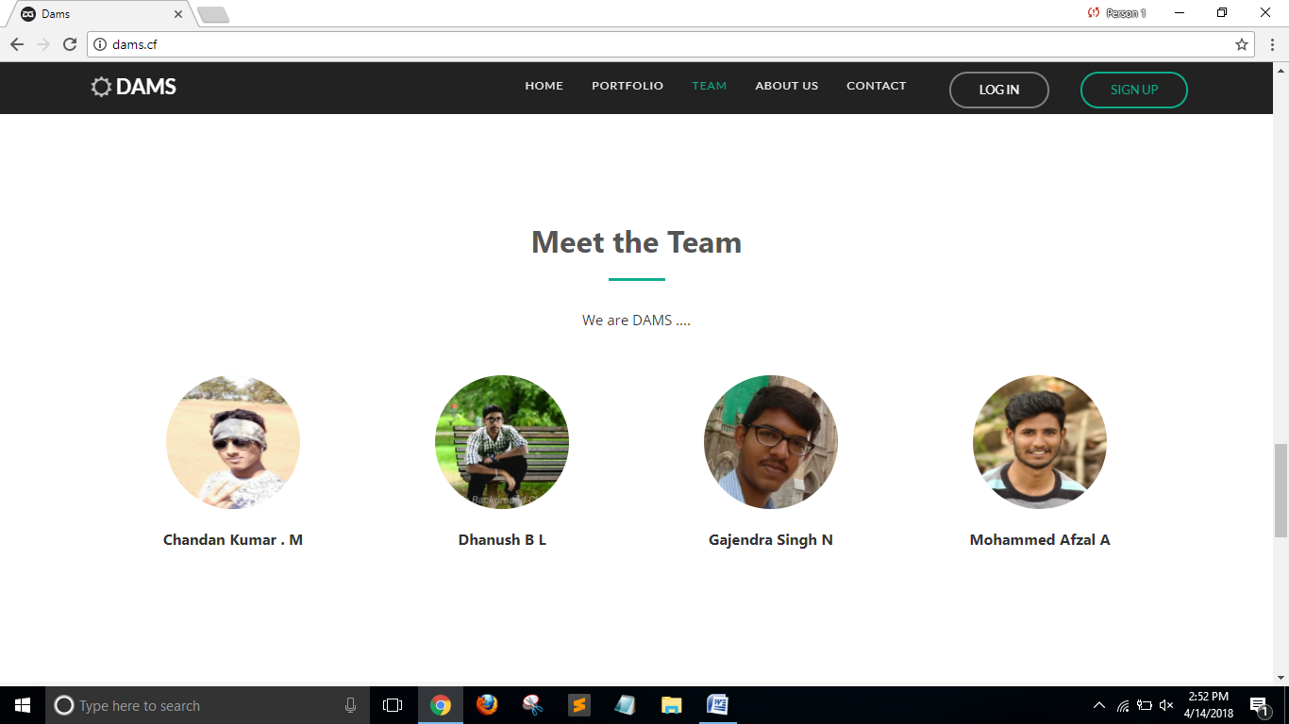

**Fig 7.2 : Meet the Team**

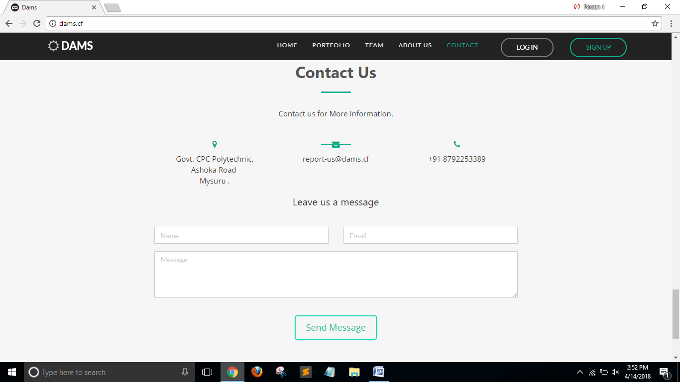

**Fig 7.3 : Feedback Form**

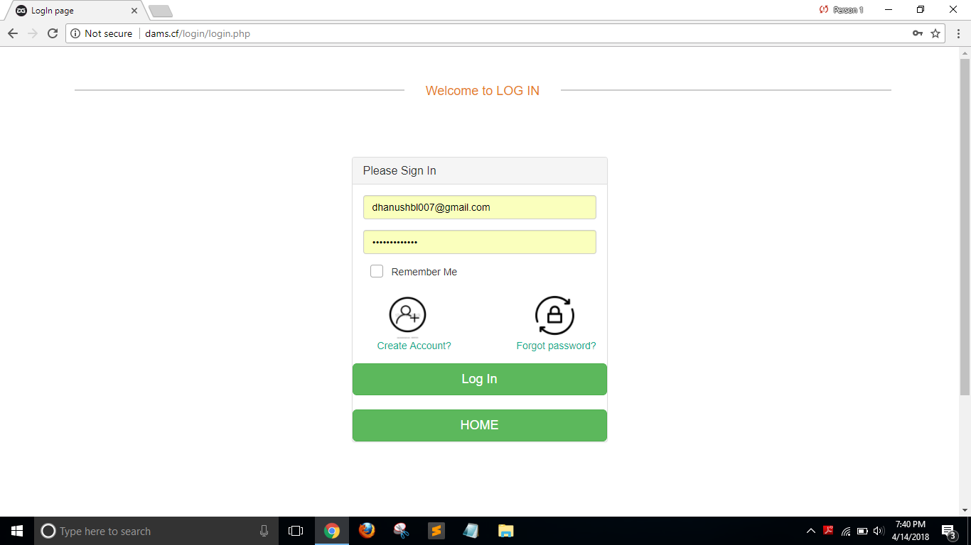

**Fig 7.4 : Login form**

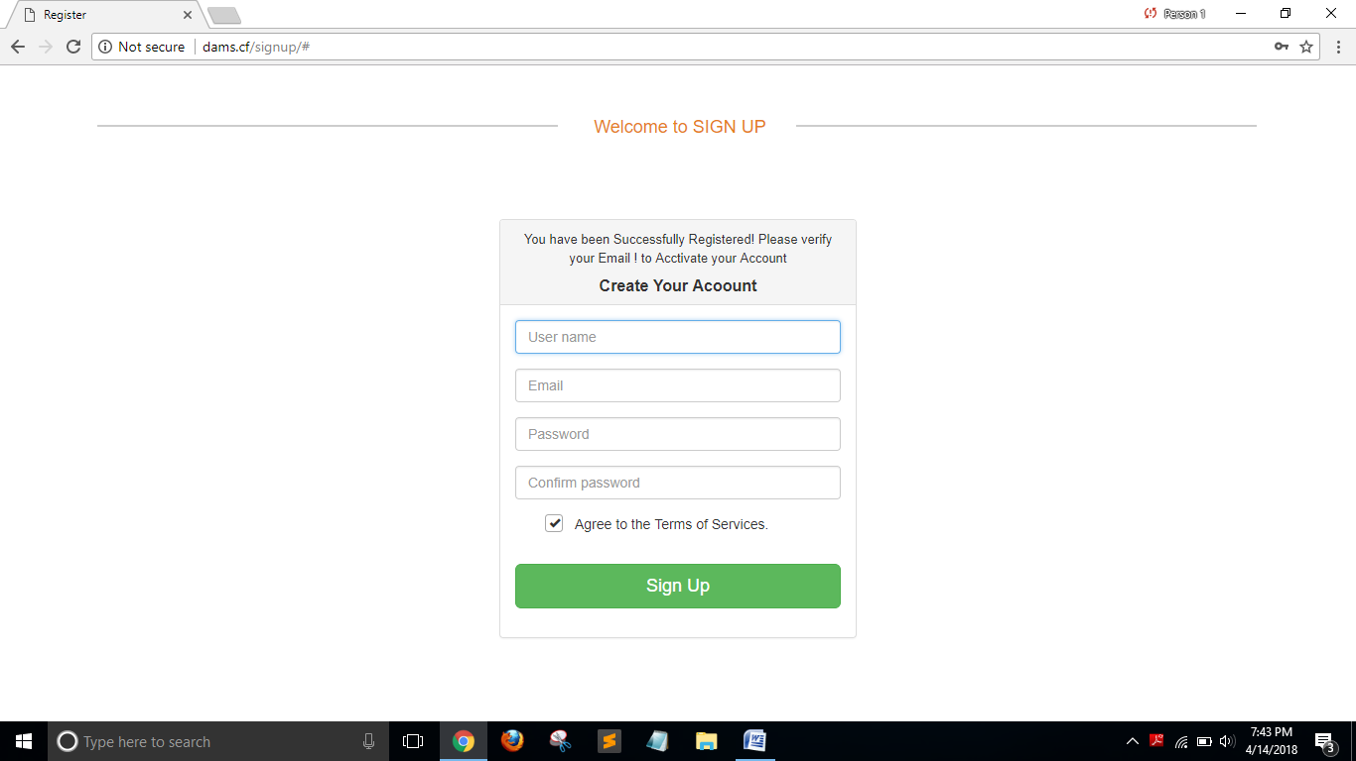

**Fig 7.5: Signup Form**

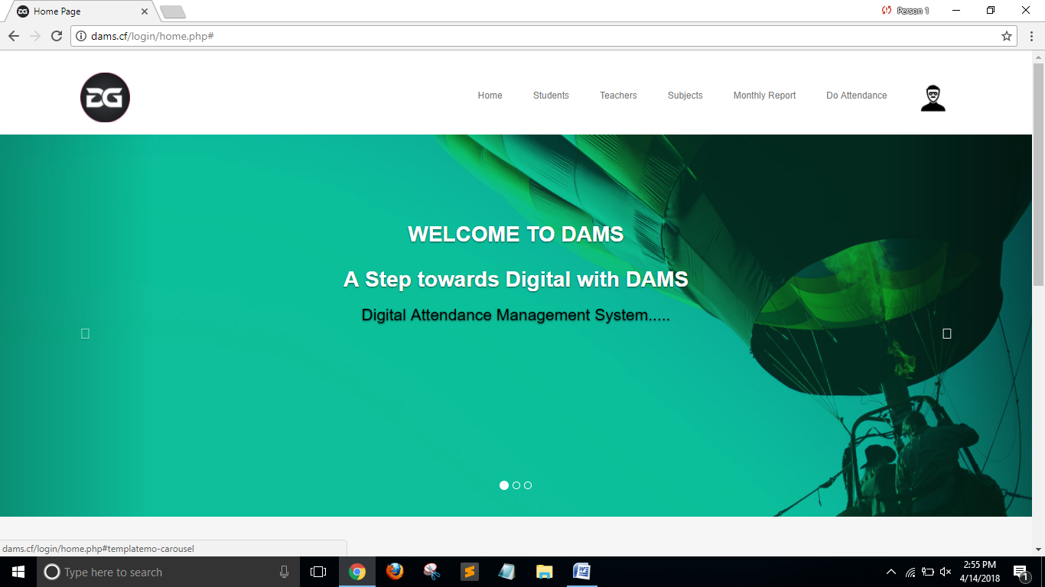

**Fig 7.6 : Home Page after Login**

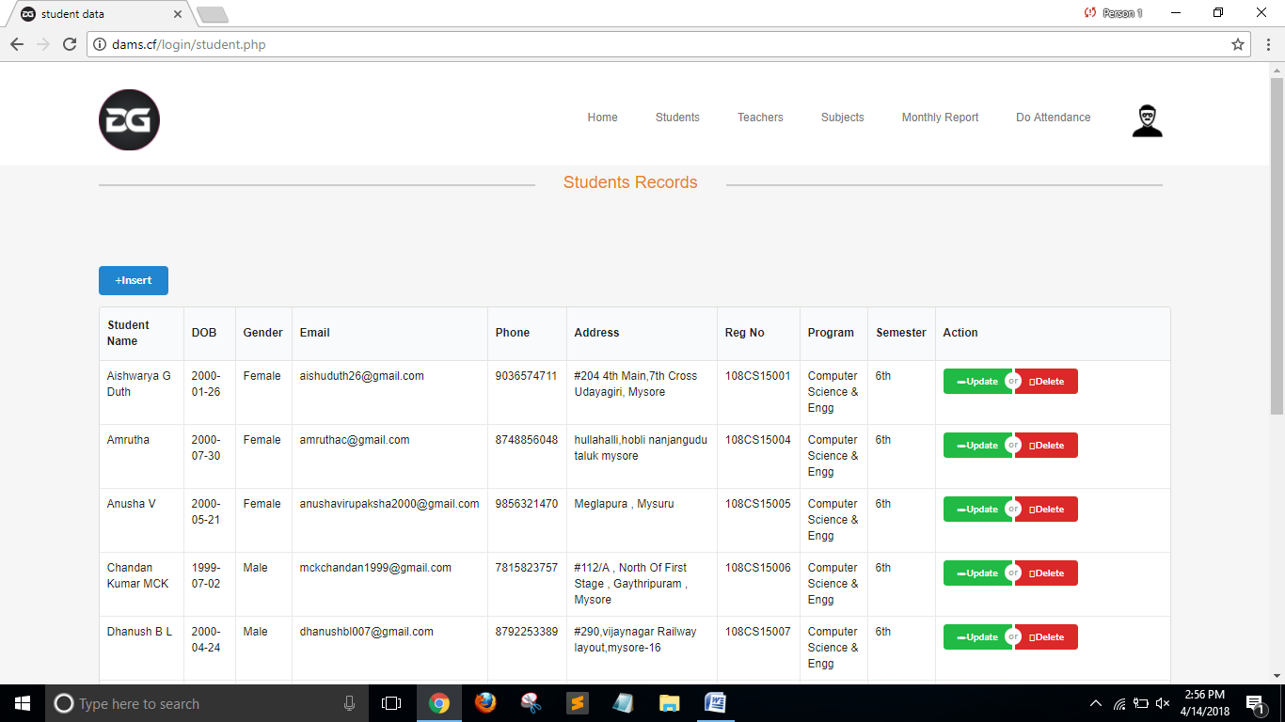

**Fig 7.7 : Displaying Student Details**

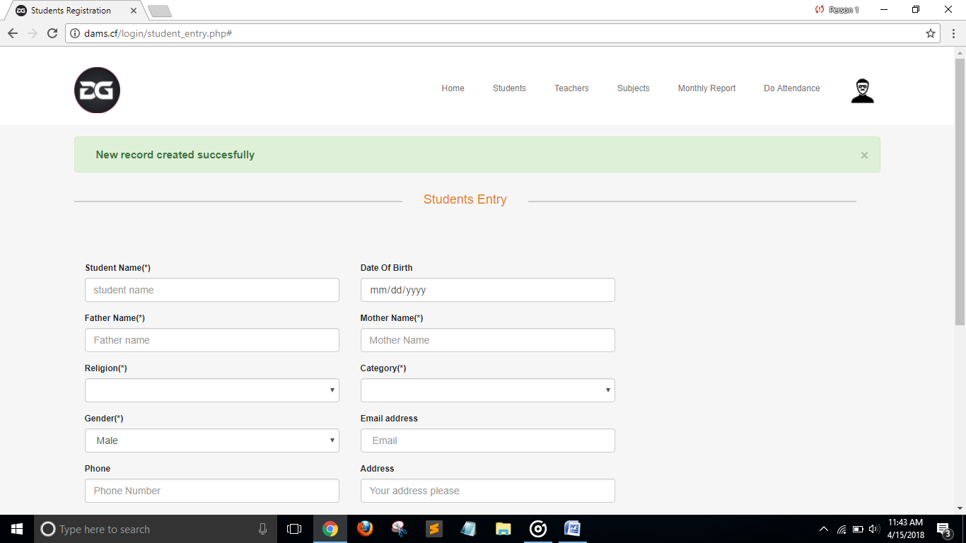

**Fig 7.8 : Insertion of Student**

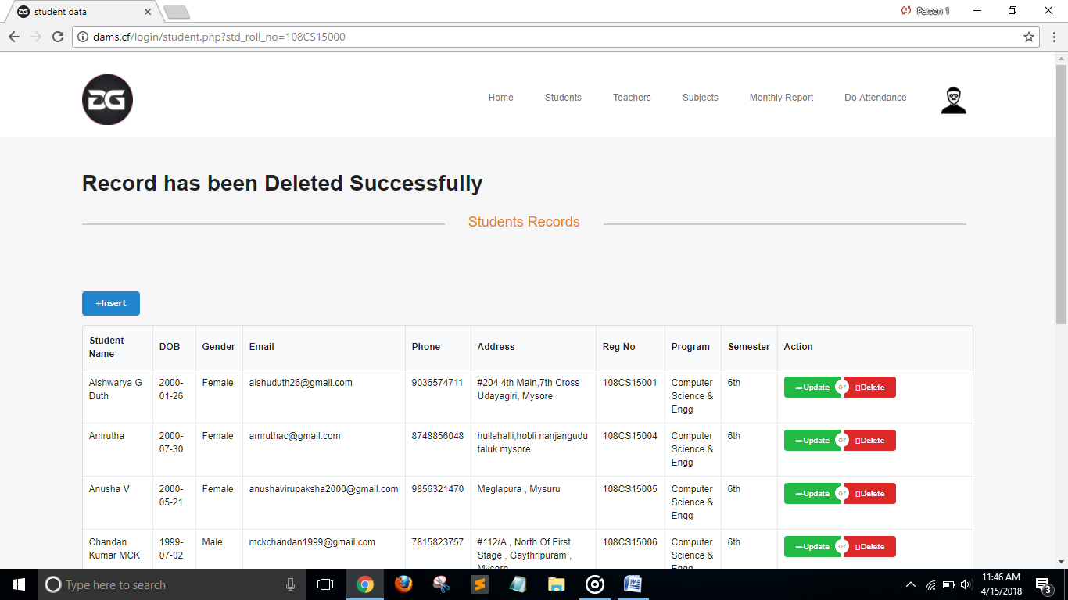

**Fig 7.9 : Deletion of Student**

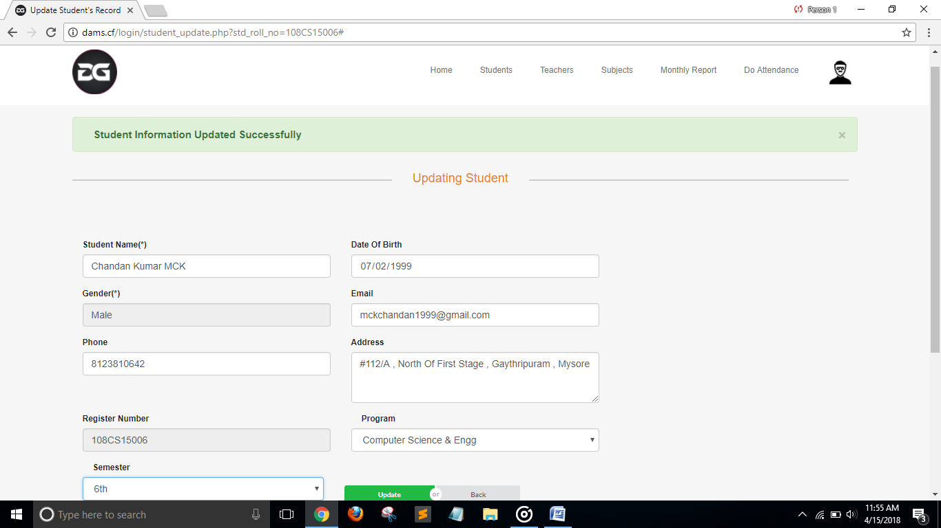

**Fig 7.10: Updation of Student Details**

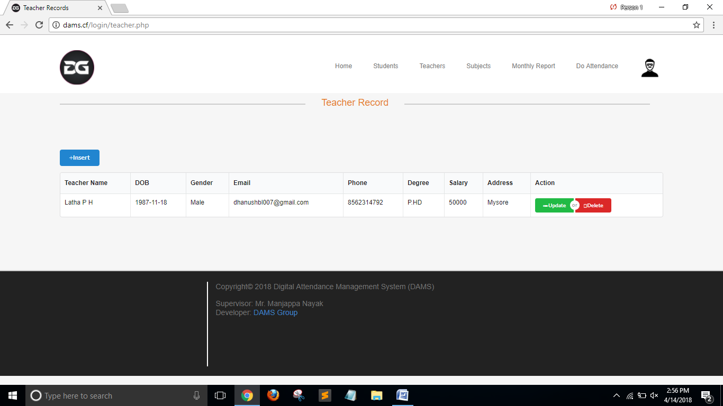

**Fig 7.11: Displaying Teachers Details**

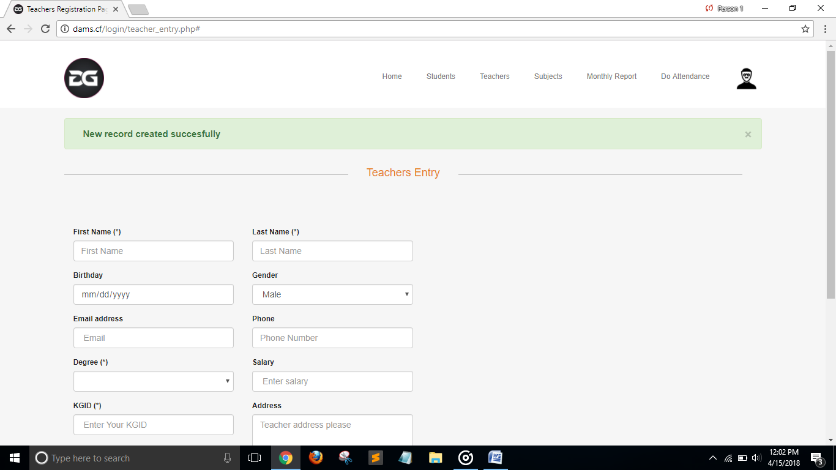

**Fig 7.12: Insertion of Teacher**

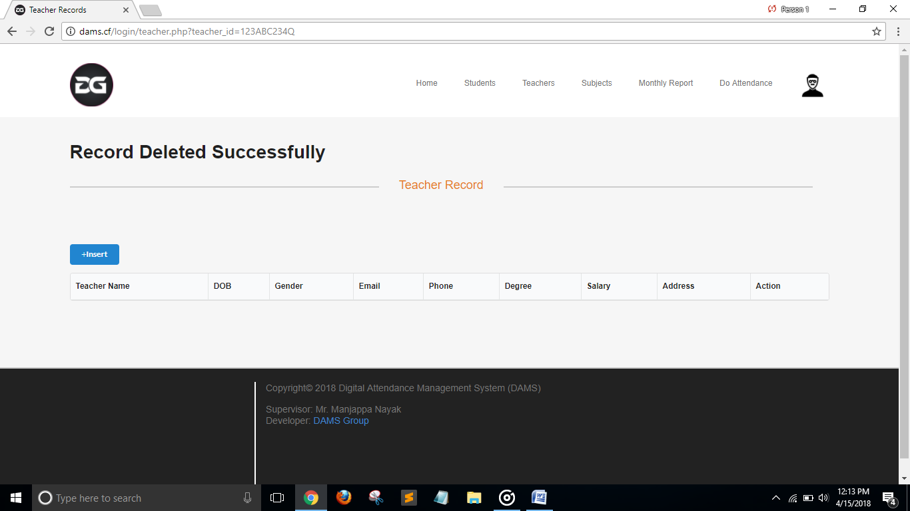

**Fig 7.13: Deletion of Teacher**

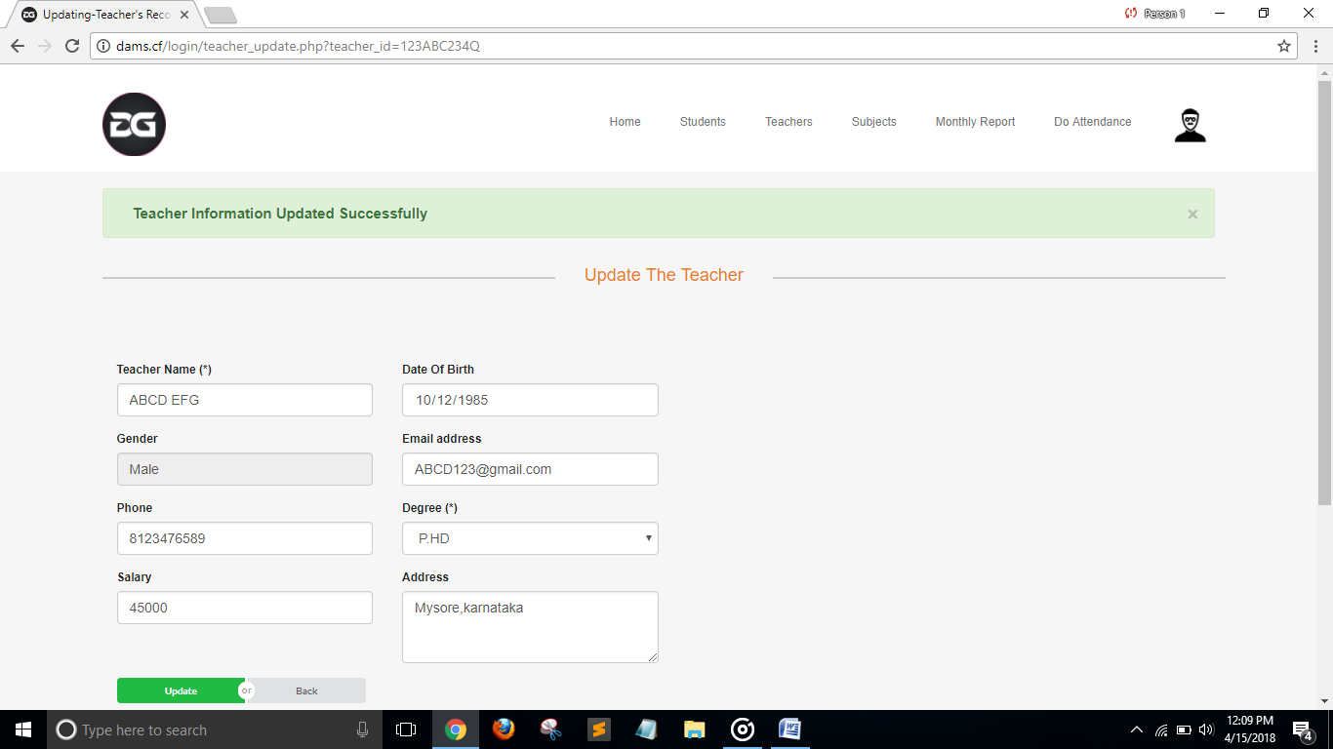**Fig 7.14 : Update the Teacher Details**

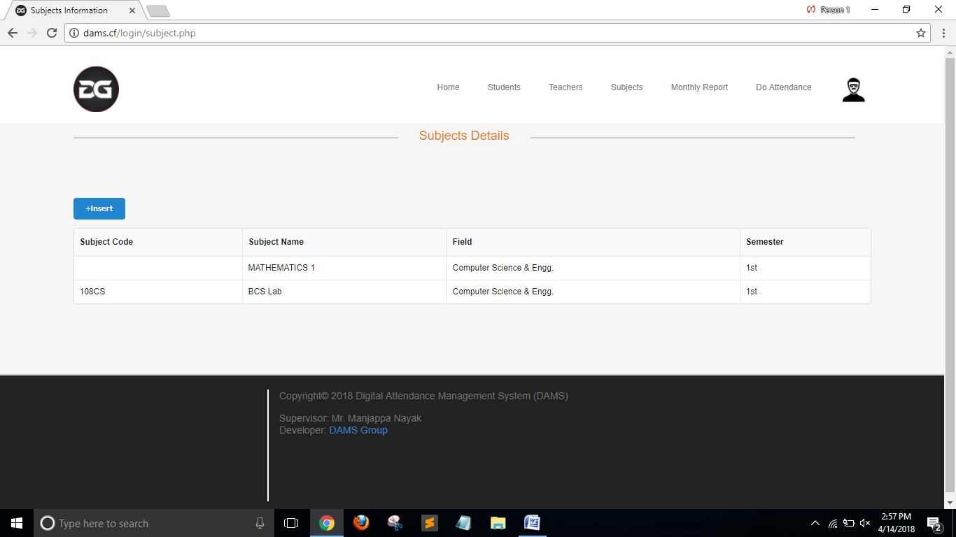

**Fig 7.15 : Displaying Subject Details**

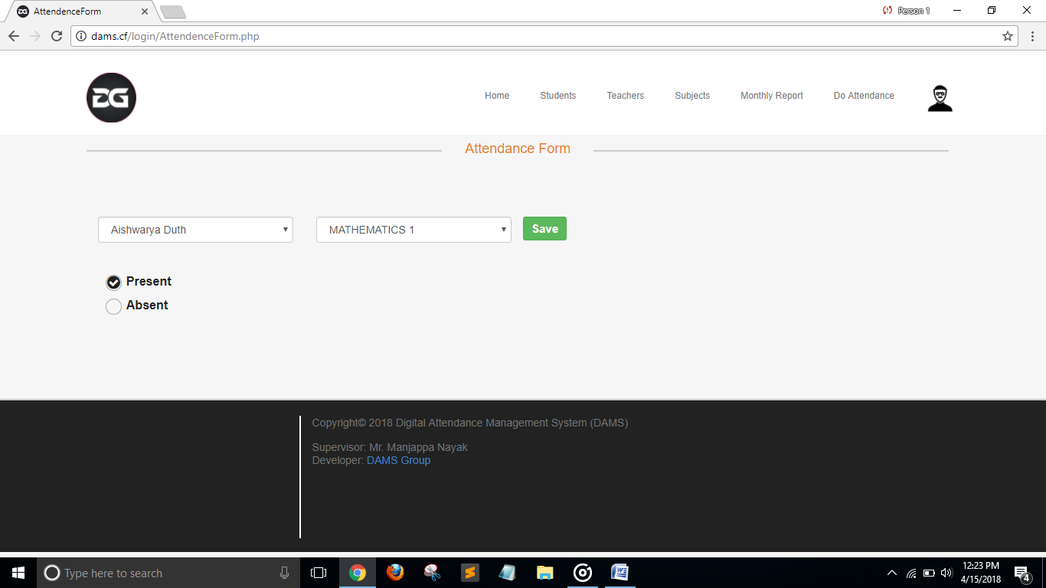

**Fig 7.16 : Do Attendance**

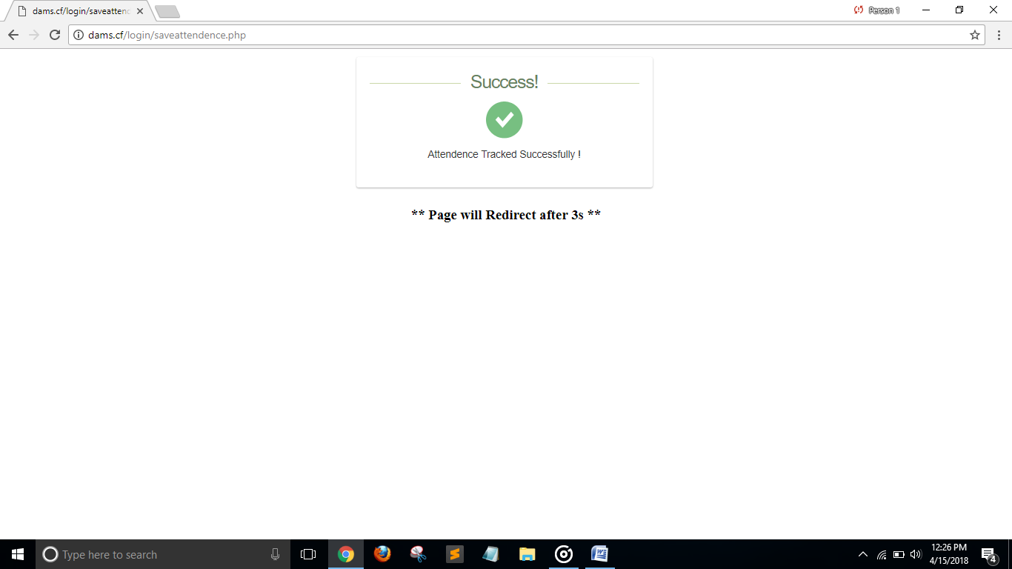

**Fig 7.17: Tracking the Attendance**

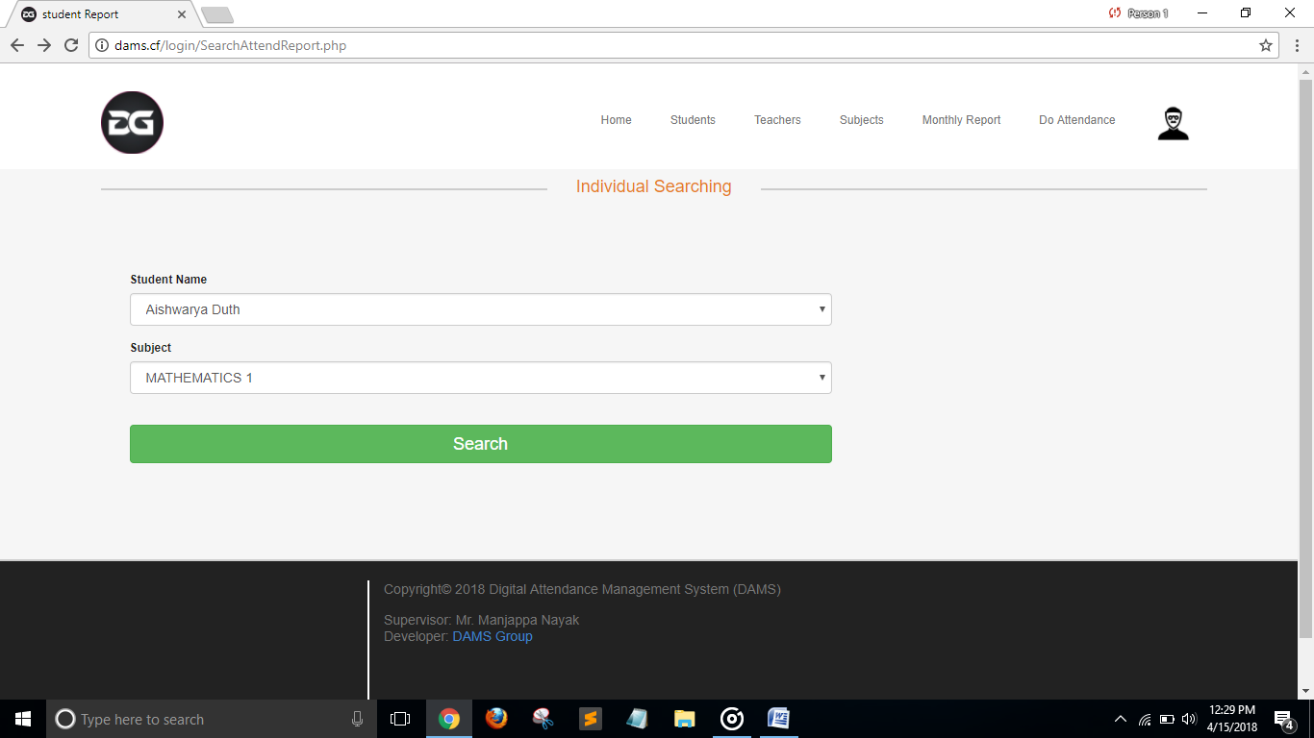

**Fig 7.18: Generating the Monthly Report**

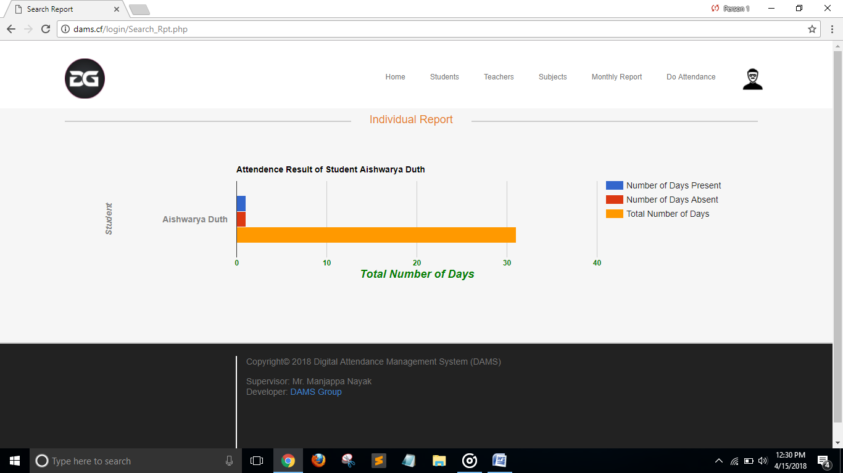

**Fig 7.19: Monthly Report**

Chapter 8

**LIMITATION OF THE PROJECT**

The problem is to provide the complete information about the college campus. In which the college staff members can access the information and will be familiar with college campus. It will provide interactive environment for the staff, students and parents by getting knowledge of student attendance .

Today in colleges student details are entered manually. The student details in separate records is a tedious task. Referring to all these records and updating is needed. There is a chance for more manual errors.  
  
**Problems in existing system**:  
• It was limited to a single system.  
• It was less user-friendly.  
• It have a lots of manual work (Manual system does not mean that we are working with pen and paper, it also include working on spread sheets and other simple software's)   
• It requires more no of employees need to work.  
• It was time consuming process.  
• The Existing system was very less secure.  
• It is unable to generate different kinds of report.  
  
**Solution to these problems**:   
The development of the new system contains the following activities, which try to automate the entire process keeping in view of the database integration approach.  
• User friendliness is provided in the application with various controls. User can make Attendance using any Smart phone .  
• The system makes the overall project management much easier and flexible.  
• It can be accessed over the Internet.  
• Various classes have been used to provide file upload and mail features.   
• There is no risk of data mismanagement at any level while the project development is under process.  
• It provides high level of security using different protocols like https etc.

Chapter 9

**Future Enhancement**

Online examination module would be introduced to conduct online examination.

Further, the faculty can upload the videos of their lectures on this site and students who had missed those classes can view those videos

There can be some enhancements which can be implemented in our project. These enhancements will surely make it feasible to be included as one of the university project java source code services which will be provided by the free download college management system project in php mobile companies and network providers. Some of the university project java source code are as below:

* In image sending module, Bluetooth connectivity is implemented to send image to the students’ attendance server. It is not implemented by us presently because of the university project java source code high cost involved in sending MMS’s.
* The text within our project should be a single word i.e. name of the university project java source code city. It should not be a sentence formed of grammatically connected words. So further improvement can be implemented to recognize sentence and interpret it with proper grammatical sentence in the college books target language.

This language emulator can be implemented as a standalone software for the college examination mobile phones. i.e. this software should be installed in the college books phone to directly get the management system developed in java translated text without sending it to the student’s attendance server and getting back the message.

Chapter 10

**Reference and Bibliography**

1. ISTQB Certification Study Guide, Dr. K.V.K.K. Prasad, Wiley-Dream tech Press, ISBN: 9788177227116
2. Programming the World Wide Web, 7th edition, Robert W.Sebesta , Pearson Education, ISBN- 9789332518827
3. Software Engineering –A Precise Approach, Pankaj Jalote, edition 2010, Wiley India, ISBN: 9788126523115.
4. <http://www.000webhost.com>
5. <http://www.stackoverflow.com>
6. <http://www.codingpassiveincome.com>
7. <http://www.quora.com>
8. http://api.google.com/charts/
9. <http://www.w3schools.com>
10. <https://en.wikipedia.org>